Assignment 1

1. Write a program to draw a pyramid of star
2. class PyramidStar {
3. public static void main(String[] args) {
4. for (int i = 0; i < 5; i++) {
5. for(int j=5-i; j>1; j--){
6. System.out.print(" ");
7. }
8. for(int j=0; j<=i; j++){
9. System.out.print("\* ");
10. }
11. System.out.println();
12. }
13. }
14. }

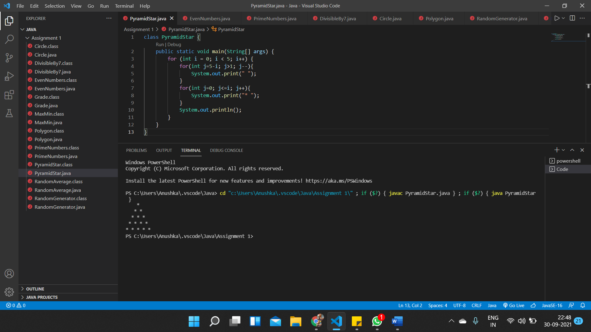

2. Write a program to display the list of even numbers between 1 to 100.

public class EvenNumbers {

    public static void main(String[] args) {

        for (int i = 2; i <=100; i+=2) {

            System.out.println(i);

        }

    }

}

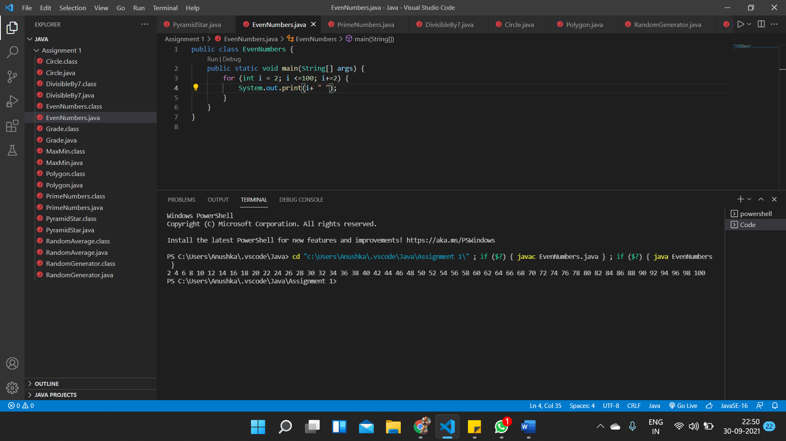

3. Write a program to display the list of prime numbers between 1 and 200.

public class PrimeNumbers {

    public static void main(String[] args) {

    for(int i=2; i<=200; i++){

        int count=0;

        for(int j=2; j<i; j++){

            if(i%j==0){

                count++;

            }

        }

        if(count==0){

            System.out.print(i);

            System.out.print(" ");

        }

    }

    }

}

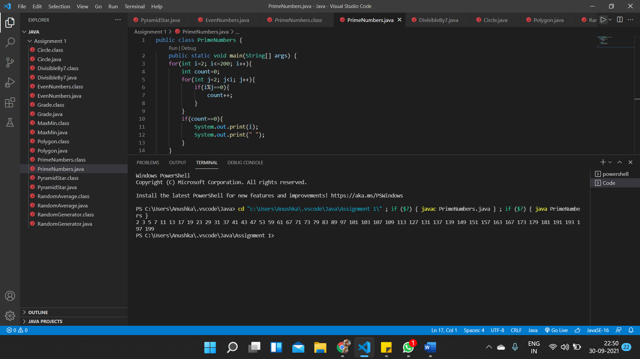

4. Write a program to find sum of all integers greater than 100 and less

than 200 that are divisible by 7

public class DivisibleBy7 {

    public static void main(String[] args) {

    int sum=0;

    for(int i=100;i<=200; i++){

        if(i%7==0){

            sum+=i;

        }

    }

    System.out.print(sum);

    }

}

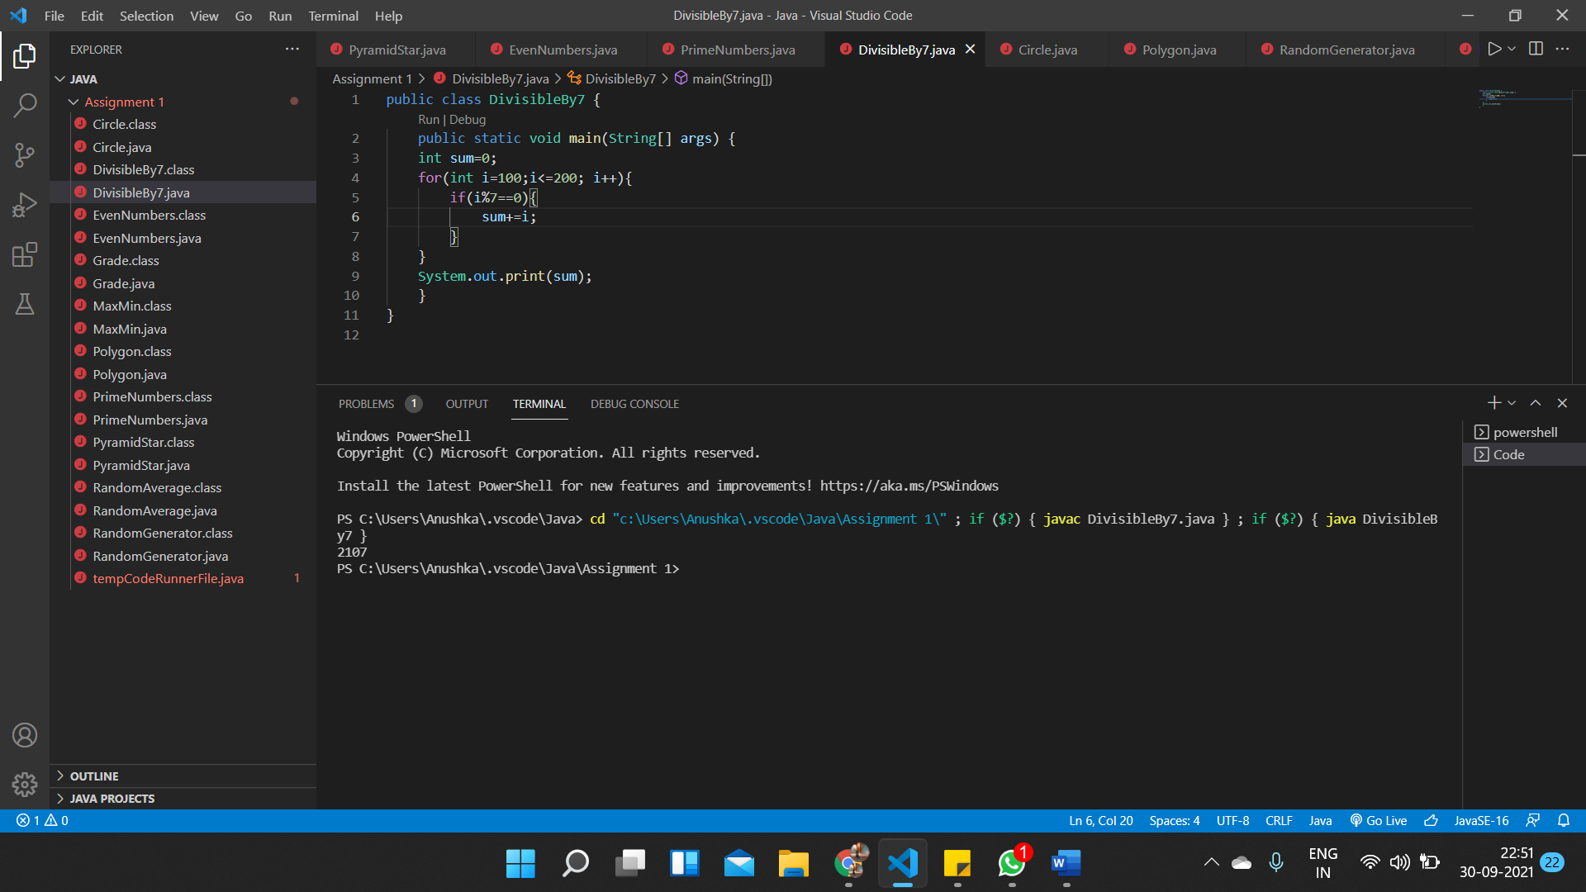

5. Find minimum and maximum of two numbers using conditional

Operator

public class MaxMin {

    public static void main(String[] args) {

    int x=10,y=5;

        if(x>y){

            System.out.println("The maximum of two numbers is "+ x);

            System.out.println("The minimum of two numbers is "+ y);

        }

        else{

            System.out.println("The maximum of two numbers is "+ y);

            System.out.println("The minimum of two numbers is "+ x);

        }

    }

}

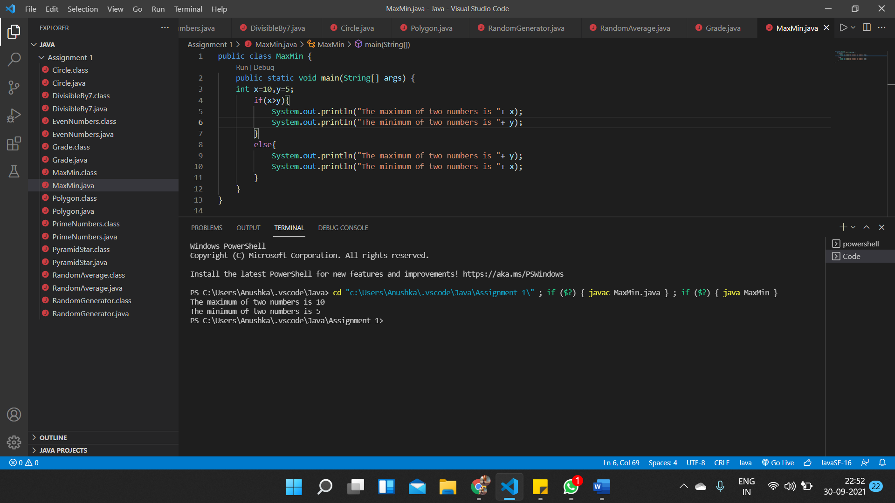

6. Create a class Circle and methods circumCircle( ) to compute

circumference of a circle and arcLength() to compute the length of the

arc for a given angle. Within the main method of class Circle create

an object which compute circumference when the radius is 10 and arc

length when the angle is 45. 7.

public class Circle {

    public static void circumCircle(double radius){

        double circumference=2\*3.14\*radius;

        System.out.println("The circumference of circle with radius " + radius + " is " + circumference);

    }

    public static void arcLength(double radius, double angle){

        double arc= (radius\*angle\*3.14)/180;

        System.out.println("The length of arc of circle with radius " +radius+ " and angle " + angle+ " is " + arc);

    }

    public static void main(String[] args) {

        circumCircle(10);

        arcLength(10,45);

    }

}

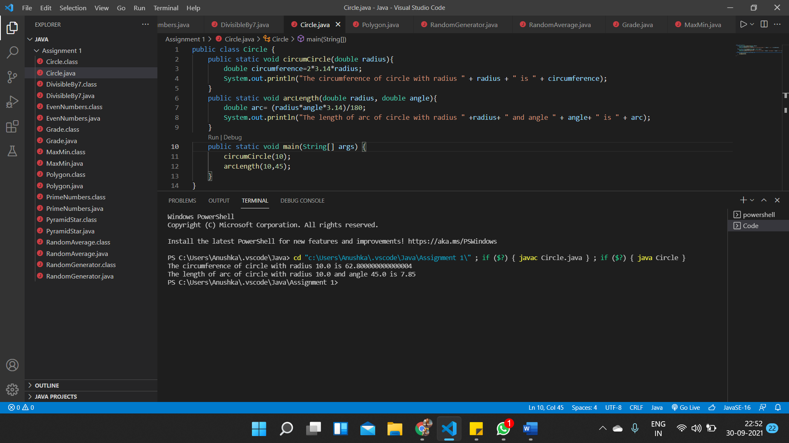

7.Write a program in which class is declared to deal with the

characteristics of regular polygons and declare methods for

determining area and parameter. The length of the side and the

number of the sides should be declared public.

public class Polygon {

    static void area(double n, double length){

        double angle= Math.toRadians(180/n);

        angle=Math.tan(angle);

        double Area=(length\*length\*n)/(4\*angle);

        System.out.println("The area of polygon with "+ n + " sides is "+ Area);

    }

    static void Perimeter(double n, double length){

        double perimeter=n\*length;

        System.out.println("The perimeter of polygon with "+ n + " sides is "+ perimeter);

    }

    public static void main(String[] args) {

        area(5, 20);

        Perimeter(5, 20);

    }

}

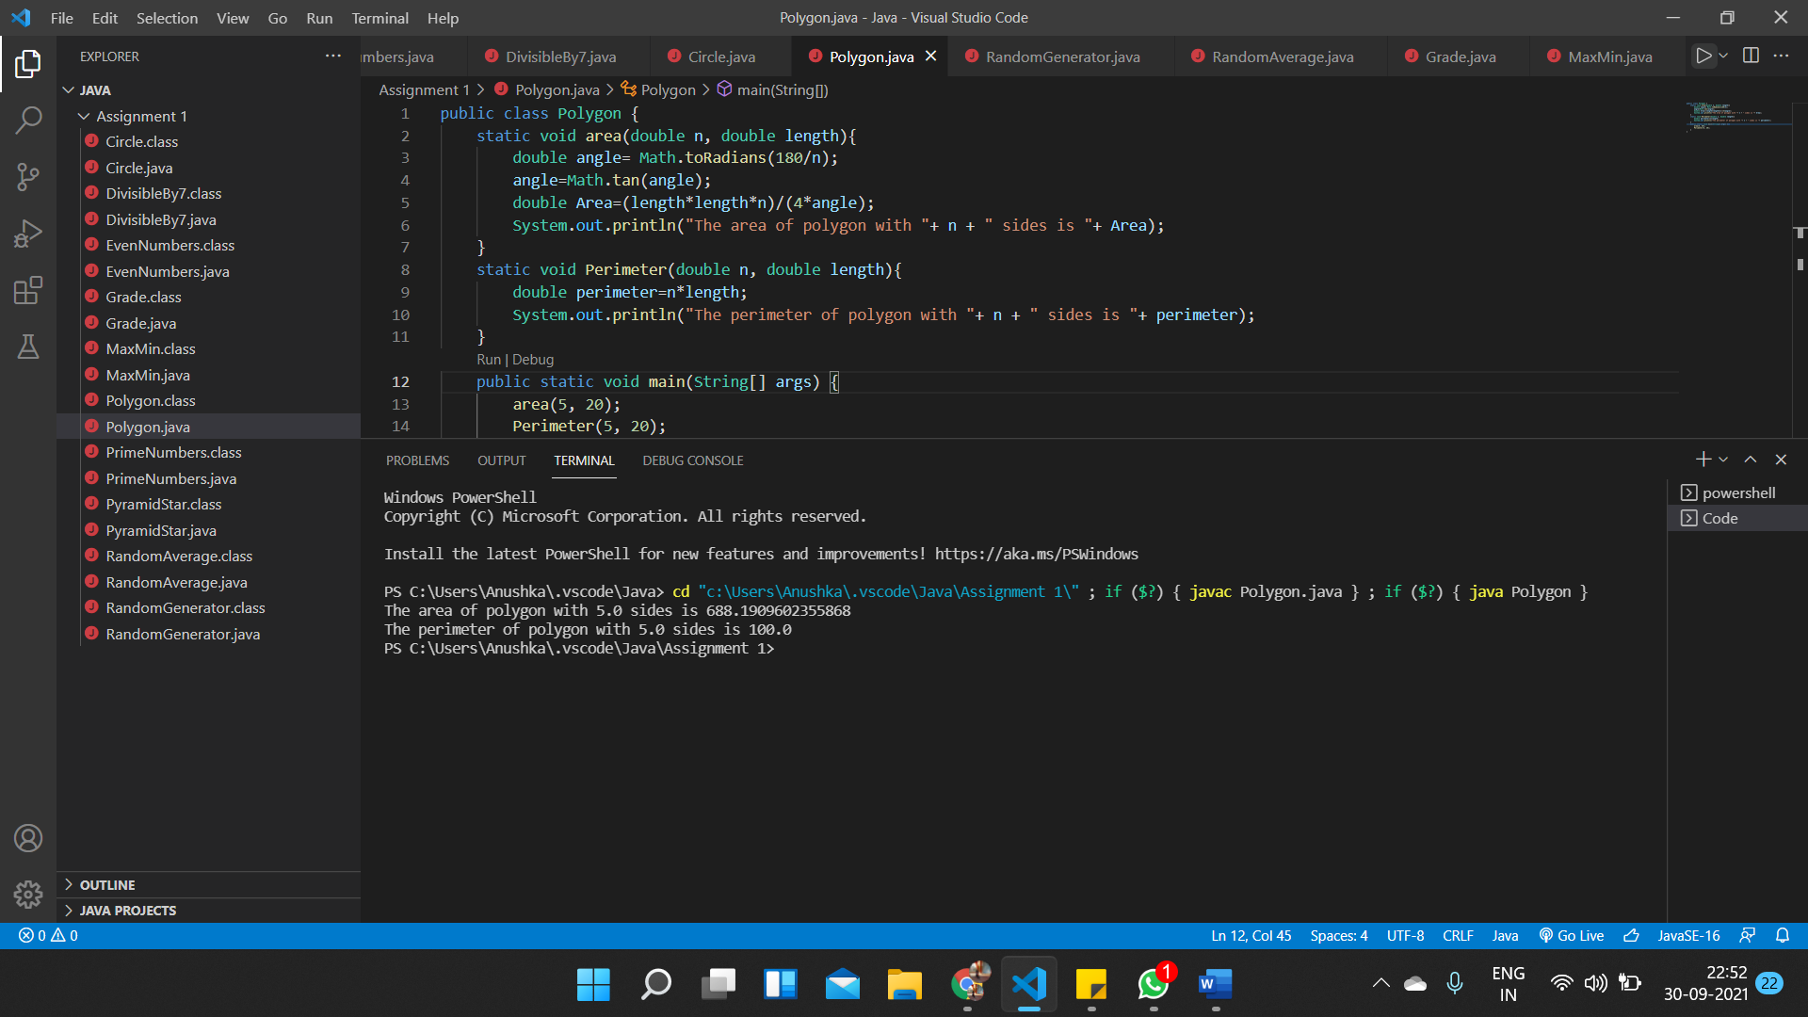

8. Write a program to generate 5 random numbers between 1 to 100 and

it should not follow with decimal point

import java.util.Random;

public class RandomGenerator {

    public static void main(String[] args) {

        Random random = new Random();

        int upperbound = 101;

        int rand1 = random.nextInt(upperbound);

        int rand2 = random.nextInt(upperbound);

        int rand3 = random.nextInt(upperbound);

        int rand4 = random.nextInt(upperbound);

        int rand5 = random.nextInt(upperbound);

        System.out.println("First random integer between 1 to 100 is: "+ rand1);

        System.out.println("Second random integer between 1 to 100 is: "+ rand2);

        System.out.println("Third random integer between 1 to 100 is: "+ rand3);

        System.out.println("Fourth random integer between 1 to 100 is: " + rand4);

        System.out.println("Fifth random integer between 1 to 100 is: " + rand5);

    }

}

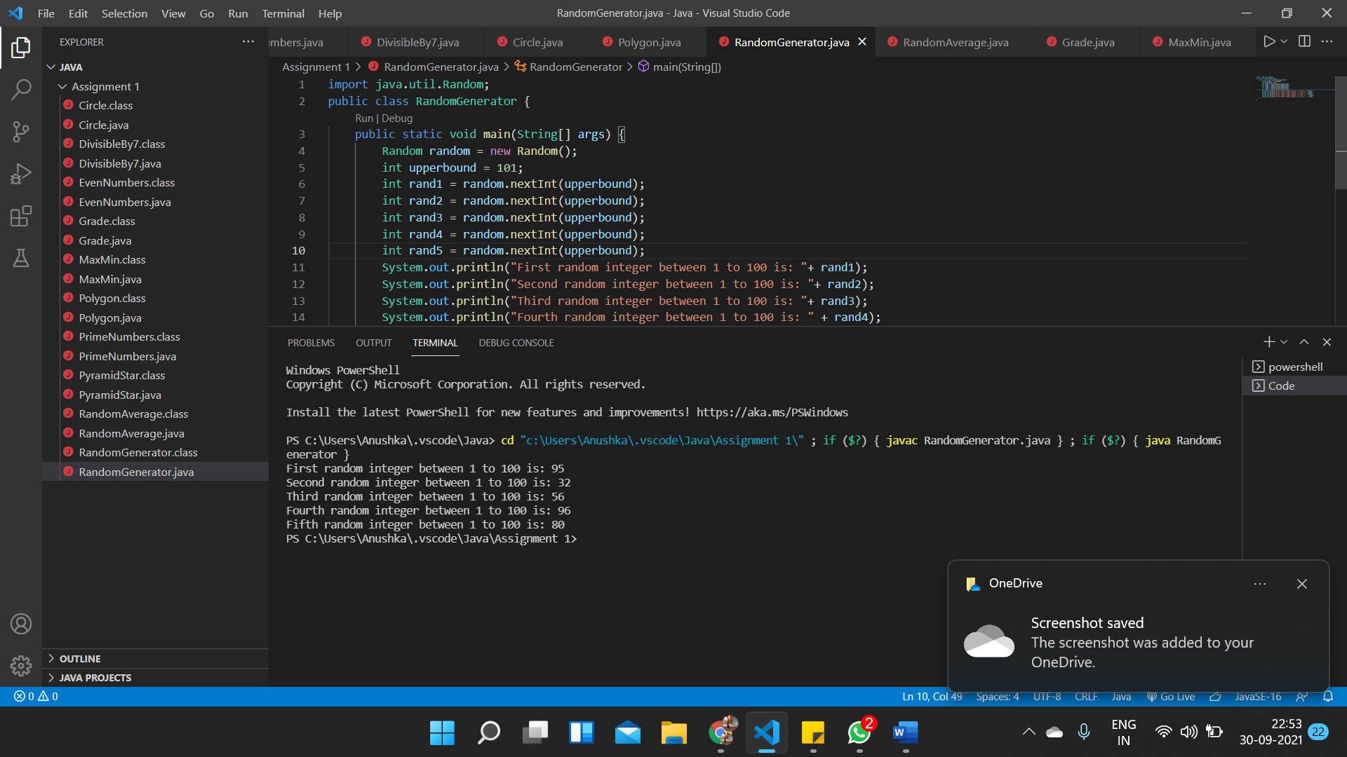

9. Write a program in which a sample of 8 random numbers are

generated and an average value is determined by a user

import java.util.Random;

public class RandomAverage {

    public static void main(String[] args) {

    Random random=new Random();

    int rand1 = random.nextInt();

    int rand2 = random.nextInt();

    int rand3 = random.nextInt();

    int rand4 = random.nextInt();

    int rand5 = random.nextInt();

    int rand6 = random.nextInt();

    int rand7 = random.nextInt();

    int rand8 = random.nextInt();

    System.out.println("The randomly generated numbers are: "+ rand1 + " "+ rand2 + " "+ rand3 + " "+ rand4 + " "+ rand5 + " "+ rand6 + " "+ rand7 + " " + rand8);

    int average=(rand1+rand2+rand3+rand4+rand5+rand6+rand7+rand8)/8;

    System.out.println("The average of these numbers is: "+average);

    }

}

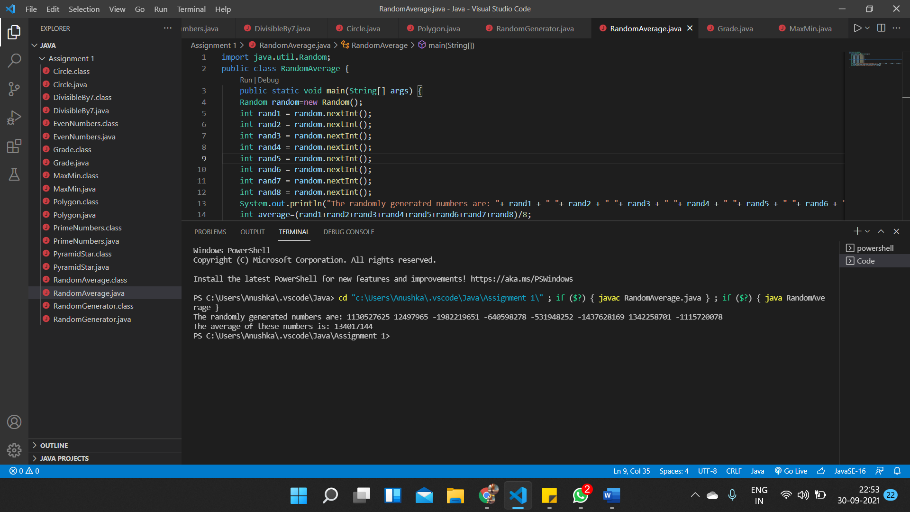

10. Write and run a java program that generates a random integer in the

range of 60 to 99and then prints the letter grade that would be

correspond to that score on a test. Divide the marks interval 60-99

into 9 intervals and grade them A+, A, A-, B+, B, B-, C+, C, C-

import java.util.Random;

public class Grade {

    public static void main(String[] args) {

        Random random = new Random();

        int innerbound=59,upperbound = 100;

        int rand = random.nextInt(innerbound, upperbound);

        System.out.println("Random integer between 60 to 99 is: "+ rand);

        if(rand>=60 && rand<=63){

            System.out.println("The grade is C-");

        }

        if(rand>=64 && rand<=67){

            System.out.println("The grade is C");

        }

        if(rand>=68 && rand<=71){

            System.out.println("The grade is C+");

        }

        if(rand>=72 && rand<=75){

            System.out.println("The grade is B-");

        }

        if(rand>=76 && rand<=79){

            System.out.println("The grade is B");

        }

        if(rand>=80 && rand<=84){

            System.out.println("The grade is B+");

        }

        if(rand>=85 && rand<=89){

            System.out.println("The grade is A-");

        }

        if(rand>=90 && rand<=94){

            System.out.println("The grade is A");

        }

        if(rand>=95 && rand<=99){

            System.out.println("The grade is A+");

        }

    }

}

